**10/2 Meeting with Dr. Woods**

**Agenda:**

General progress-

* Decided upon an air quality/humidity/temp/pressure/biosensor node
* Shows our modular capabilities
* Possible NFC, utilization of Bluetooth or LoRa, solar powered

Microcontroller progress-

* I forgot that debuggers are necessary
* Programming IDE: Atmel Studio 7
* Might also want dev kits for the processor(s) to check current draw
* Also need to scrounge breakout boards

Communications progress-

* We ordered a Bluefruit SPI board
  + Waiting to get measurements with this
* If we do not get good results from Bluefruit, we could look into other boards
* We also ordered a LoRa board

Power progress-

* 3 batteries ordered
  + https://www.digikey.com/product-detail/en/illinois-capacitor/RJD2430C1ST1/1572-1630-ND/6596418
* A BQ25505EVM and a BQ25570EVM coming, free of charge, from TI
* Indoor solar is a challenge
  + Ordered solar cells for testing
* Evaluation boards
  + Bq25505 ultra low power harvester power management IC with Boost Charger Evaluation Model
  + Ultra Low Power Management IC, Boost Charger Nanopowered Buck Converter
* Meeting with Eric Welsh tonight

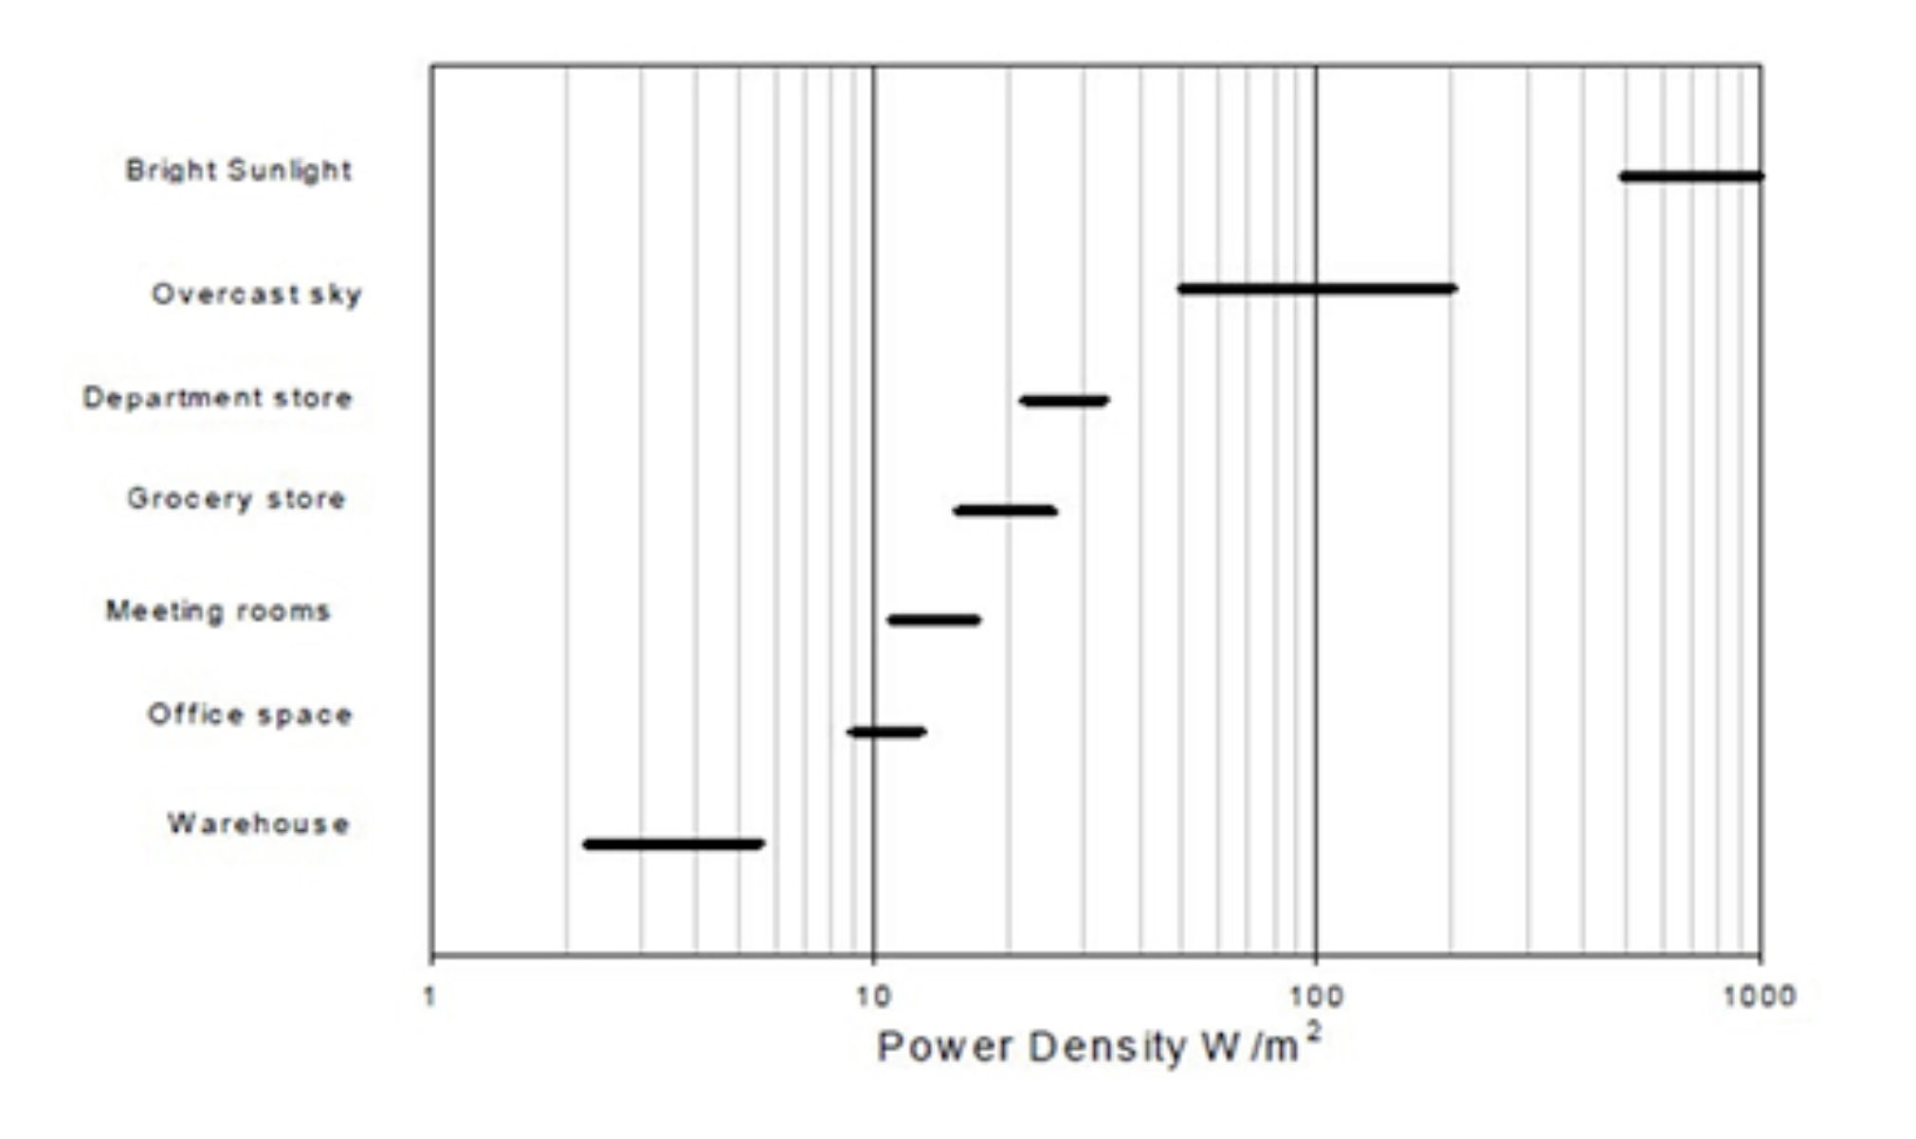

Sensor progress-

* Many sensors detect presence/concentration of VOCs but not specific compound
* Humidity + temp, air quality all seem reasonable
* Adafruit!
* [Sensors Table](https://docs.google.com/document/d/1M9AqtBZ1X1MmPR3ByvbKpMrEIOmMwB2ql1wWzspbGuw/edit?usp=sharing)

Questions for Dr. Woods-

* Documentation
* Gantt charts
* General upcoming due dates
* How is our progress?
  + Are we where we need to be?
  + Are we BETTER than where we need to be?

Notes!

* It’s wednesday, that’s terrifying - Robby
* “Basically I’m 72 now, so I’ll retire” - Brady
* Air qual/temp/pressure/bio sensor node
  + Anything we will not sense? Flood
  + Passive sensors- so no send signal (radar, lidar)
* Showcase modular capabilities
* Possible NFC, utilize bluetooth/LoRa, solar-powered
* Competitor for wifi- HALO- Robby will look more into it
* BT: lots of industrial campuses have wifi all over
* JH: Does WIFI has lots of overhead? HALO has less overhead- GW
* JH: need debugger for processors- 2 microcontrollers samL10, samL21
  + Cost ~$140, while processors cost like $4
  + Might use dev kit to check current draw
* BT: for prototype 1, just use launchpad to give us options. Eventually get an ARM, plus want room to grow
  + JH: or could just do adafruit featherboard. But if we use launchpad, then we’re not progressing toward final product, since that will get thrown out no matter what
* RF: bluefruit SPI, LoRa
* What’s different from featherboard?
  + Large PCB w/ processor, arduino IDE
  + We’re adding energy harvesting, on-board sensor
  + Not trying to make it easy-to-use, trying to make it easy for Octavo to reduce size
* Batteries ordered
  + Energy harvesters coming to us from TI
* Solar panels- need to experiment with indoor conditions
  + Will it work when we need it? How much room light does it take?
* Sensors- need to find application then find sensor to implement
  + Just order the temp/ humidity sensor right now, work on finding passive sensors?
  + Monitor for fume hoods w/ microswitch to see if the hood is open
* Rachel talk to Dr. Hunter- Needs-finding class
* Stick-up to monitor power use- sensor network to figure out when the light is left on